Earth’s Destructive Forces

|  |  |
| --- | --- |
| Earth’s Destructive Forces | Features on Earth’s surface such as mountains and valleys are created over hundreds of years, however, some events or **forces**, such as **earthquakes, floods volcanoes** and **landslides** occur very rapidly or fast and can completely change the surface of the Earth within hours or days. These forces’ damage cannot be reversed or fixed, as it can with blizzards or tornadoes. Types of weather are not a destructive force. |
| Volcanoes | Volcanoes erupt when **magma** from the Earth’s mantle reaches the surface. The magma is then called **lava** as it flows down the sides and hardens as rock. These eruptions can create volcanic mountains in a matter of days. Volcanoes can erupt violently or slowly. This can happen on land or underneath the water on the ocean floor destroying everything in it’s path. |
| Earthquakes | Earthquakes are caused when rocks along plate boundaries, which make up the Earth’s crust, move against each other and get stuck. The pressure builds and then suddenly releases the energy in the formic of shaking vibrations that spread outward, like the rings on the surface of the water when a pebble is thrown in. These **seismic waves** can completely destroy land, bridges, and buildings and kill many people. |
| Landslides | Landslides occur when small or large sections of the Earth suddenly collapses, falls or slips. This can be caused by **seismic waves**, flooding or when the soil has become too wet and slumps downward. These landslides can cause instant and complete destruction to hillsides, houses, streets and towns. |
| Floods | Floods are what happens when large amounts of water move rapidly into a place it usually doesn’t cover. This is usually caused when there is a lot of rain in a short amount of time. This makes nearby rivers overflow. It can also flood because city sewers or water canals cannot drain away the water fast enough. Flooding can cause extreme and fast **weathering** of the earth as it **erodes** away dirt and earth. |

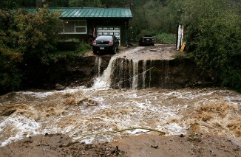Earth’s Destructive Forces

Floods

are what

happens when

large amounts of water

move rapidly into a place it

usually doesn’t cover. This is

usually caused when there is a lot of

rain in a short amount of time. This makes

nearby rivers overflow. It can also flood because

city sewers or water canals cannot drain away the water

fast enough. Flooding can cause extreme and fast **weathering**

of the earth as it **erodes** away dirt and earth.

Volcanoes

erupt when

**magma** from the Earth’s

mantle reaches the surface.

The magma is then called **lava** as

it flows down the sides and hardens as

rock. These eruptions can create volcanic

mountains in a matter of days. Volcanoes can

erupt violently or slowly. This can happen on land or

underneath the water on the ocean floor destroying everything in it’s path.

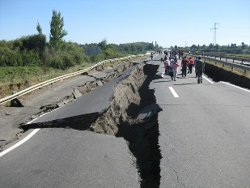

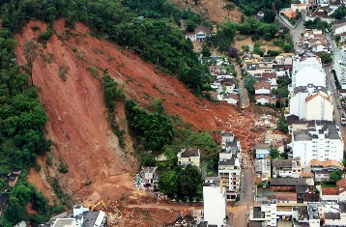

Landslides

occur when small or

large sections of the

Earth suddenly collapses, falls

or slips. This can be caused by

**seismic waves**, flooding or when the soil

has become too wet and slumps downward.

These landslides can cause instant and complete

destruction to hillsides, houses, streets and towns.

Earthquakes

are caused when

rocks along plate bound-

aries, which make up the Earth’s

crust, move against each other and

get stuck. The pressure builds and then

suddenly releases the energy in the formic of

shaking vibrations that spread outward, like the

rings on the surface of the water when a pebble is

thrown in. These **seismic waves** can completely destroy land,

bridges, and buildings and kill many people.

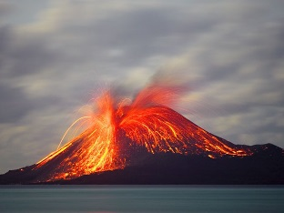

Features on Earth’s surface such as mountains and valleys are created over hundreds of years, however, some events or **forces**, such as **earthquakes, floods volcanoes** and **landslides** occur very rapidly or fast and can completely change the surface of the Earth within hours or days. These forces’ damage cannot be reversed or fixed, as it can with blizzards or tornadoes. Types of weather are not a destructive force.

Volcanoes Earthquakes Floods

Earth’s Destructive Forces Landslides

